Template Official Certificate

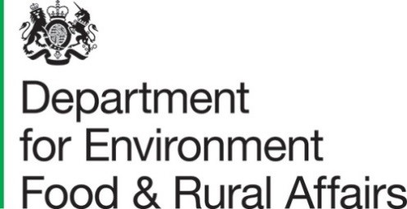

Official Certificate for Agri-food Prohibited & Restricted Goods moving from Great Britain to Northern Ireland
(Covers period – 25th January to 14th February 2021)
Official declaration
I, the undersigned official, hereby declare that I have reviewed the standards and processes in place by add company here for the supply of Agri-food Prohibited and restricted goods moving to Northern Ireland and that these, together with relevant historical records, show that the trader is only moving products to the NI market that comply with retained EU legislation on food hygiene and animal health, (including that which implemented Council Directive 2002/99/EC).

Signature:
Name: ……………………………………………………… [full name of Official (FCCO/OV]
Address:

minced meat of poultry, of ratites and of wild game-birds, frozen or chilled, - chilled minced meat from animals other than poultry, - chilled meat preparations, - any unprocessed meat produced from meat initially imported in Great Britain from the EU’s SPS area

